Creating Reports

1. Select “Create Report” button in the top right corner.



1. Give the report a descriptive name
2. For source type, select **Table**
3. Choose the Table you would like to draw your statistics from
   1. All ACP tables begin with “x_wsos_acp_” ex. [x_wsos_acp_participant]
4. Select “Next”. Your data should populate on the right of the report application.
   1. It is worth noting that your table view is set by your most recent preferences implemented on that table, so if you need to change any column headers, you will need to do so outside of the report

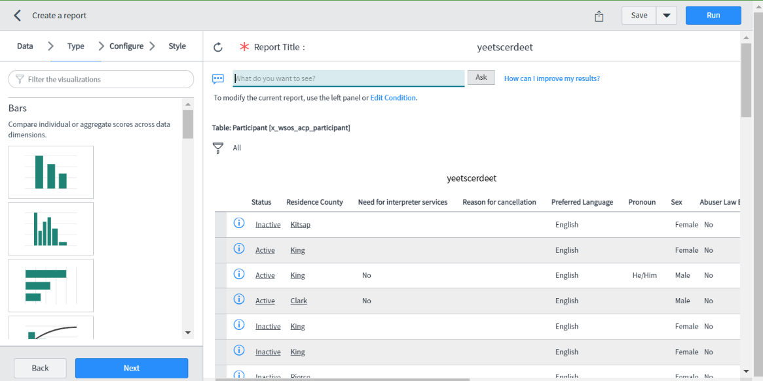

1. Choose a report “Type”:
   1. Bar
   2. Pie/Donut
   3. Scores
   4. Other

**Bar)** A bar graph is configured using the following information:

* **Group by**: select the column that will represent the x-value
  + **Additional group by**: select additional columns that can be applied to the rest of the configuration, creates a drop-down under the bar chart to switch which column is being visualized
* **Stack by**: break the bars into multiple chunks to represent another variable’s association within the first
* **Aggregation**: select the data function performed on the x-values to establish the y-values
* **Max number of groups**: select the maximum number of bars (x-values) for the report to output (40 is the most possible)

**Style**: allows for basic aesthetic changes of the report i.e. colors, font size, labels, etc.

**Pie**

**Scores**